K L UNIVERSITY
FRESHMAN ENGINEERING DEPARTMENT
A Project Based Lab Report On

Quiz Assessment & Performance Analytics System

SUBMITTED BY:
2500030707 S. SUJITH SAI
2500030578 K. PRASANTH KUMAR
2500030745 G. MANOJ
2500030765 C. JOYTHIRADITYA

UNDER THE ESTEEMED GUIDANCE OF Dr. SREERAM

ASSISTANT PROFESSOR



KL UNIVERSITY
Green fields, Vaddeswaram – 522 502 Guntur Dt., AP, India.

DEPARTMENT OF BASIC ENGINEERING SCIENCES



CERTIFICATE

This is to certify that the project based laboratory report entitled “Quiz Assessment & Performance Analytics System” submitted by S. SUJITH SAI, K. PRASANTH KUMAR, G. MANOJ, C. JOYTHIRADITYA bearing Regd. No. 2500030707, 2500030578, 2500030745, 2500030765. to the Department of COMPUTER SICENCE ENGINEERING , KL University in partial fulfillment of the requirements for the completion of a project based Laboratory in “Computational Thinking for Problem Solving (24SC1102)” course in I B Tech I Semester, is a Bonafede record of the work carried out by him/her under my supervision during the academic year 2024 – 2025.

PROJECT SUPERVISOR HEAD OF THE DEPARTMENT Dr. SREERAM Dr. D. HARITHA

ACKNOWLEDGEMENTS

It is great pleasure for me to express my gratitude to our honorable President.

Sri. Koneru Satyanarayana, for giving the opportunity and platform with facilities in accomplishing the project-based laboratory report.
I express sincere gratitude to our Director Dr. A. Jagdeesh for his administration towards our academic growth.
I express sincere gratitude to our Coordinator and HOD-BES Dr. D. Haritha for her leadership and constant motivation provided in successful completion of our academic semester. I record it as my privilege to deeply thank you for providing us with the efficient faculty and facilities to make our ideas into reality.
I express my sincere thanks to our project supervisor Dr. SREERAM for her novel association of ideas, encouragement, appreciation, and intellectual zeal which motivated us to venture this project successfully.
Finally, we are pleased to acknowledge our indebtedness to all those who devoted themselves directly orindirectly to making this project a success.

2500030707 S. SUJITH SAI
2500030578 K. PRASANTH KUMAR
2500030745 G. MANOJ
2500030765 C. JOYTHIRADITYA

ABSTRACT

The Quiz Assessment & Performance Analytics System (QAPAS) is a Python-based application designed to facilitate efficient quiz management, automated evaluation, and detailed performance analysis of users. The system aims to enhance the learning and assessment process by providing a structured platform for conducting quizzes and tracking user progress.The application allows administrators to create, update, and manage quizzes with multiple question types such as multiple-choice questions (MCQs). Users can attempt quizzes through a simple interface, and the system automatically evaluates their responses in real- time. Python is used as the core programming language due to its simplicity, flexibility, and powerful libraries for data handling and analysis.
A key feature of QAPAS is its performance analytics module, which generates insights such as scores, accuracy, time taken, and topic-wise performance. These analytics help users identify their strengths and weaknesses, enabling targeted learning and improvement. The system may also store data using file handling or databases like SQLite for efficient data management.Overall, QAPAS provides a scalable and user- friendly solution for digital assessments, making it suitable for educational institutions, online learning platforms, and self-assessment purposes. The use of Python ensures easy development, maintainability, and future enhancements such as graphical dashboards and AI-based recommendations.

INDEX

S.NO | TITLE | PAGE NO
1 | Introduction | 6
2 | Aim of the Project | 7
2.1 | Advantages & Disadvantages | 8
2.2 | Future Implementation | 9
3 | Software & Hardware Details | 10
4 | Data Flow Diagram | 11
5 | Algorithm for each module | 12
6 | Implementation | 13-15
7 | Integration and System Testing | 16-18
8 | Conclusion | 19

INTRODUCTION
The Quiz Assessment & Performance Analytics System (QAPAS) is a Python-based software application developed to modernize the process of conducting quizzes and analyzing user performance. In today’s digital learning environment, traditional methods of assessment are time-consuming, less interactive, and often lack detailed feedback. QAPAS addresses these challenges by providing an automated, efficient, and user-friendly platform for both quiz management and performance evaluation.

This system enables administrators or educators to create and manage quizzes easily, while users can attempt them in an interactive way. The application automatically evaluates responses, calculates scores, and provides instant results. By using Python, the system benefits from a simple syntax, rapid development, and the ability to integrate with databases and analytical tools.

A major advantage of QAPAS is its ability to generate detailed performance analytics. It not only shows the final score but also provides insights such as accuracy, time taken, and topic-wise performance. This helps users understand their strengths and weaknesses and improve their learning strategies.
The system is designed to be flexible and scalable, making it suitable for schools, colleges, online learning platforms, and self-assessment purposes. With further enhancements, such as graphical dashboards and intelligent recommendations, QAPAS can become a powerful tool in the field of digital education and assessment.

- Easy to learn
- Structured language
- It produces efficient programs.
- It can handle low-level activities.
- It can be compiled on a variety of computers.

AIM

The primary aim of the Quiz Assessment & Performance Analytics System (QAPAS) is to develop a Python-based application that enables efficient quiz management, automated evaluation, and detailed performance analysis of users. The system is designed to simplify the assessment process while providing accurate and instant results.

It aims to:

  - Provide an easy-to-use platform for creating and attempting quizzes
  - Automate the evaluation process to save time and reduce errors
  - Generate detailed performance analytics such as scores, accuracy, and progress
  - Help users identify their strengths and weaknesses for better learning outcomes
  - Support digital and self-paced learning in an efficient and scalable manner

Overall, the goal is to enhance the quality of assessments and improve user learning through data-driven insights using Python technology.

ADVANTAGES
The QAPAS offers several benefits that improve both the assessment process and user learning experience:

Automated Evaluation
The system automatically checks answers and calculates scores, saving time and reducing human errors.

Instant Results
Users receive immediate feedback after completing a quiz, which helps in quick learning and improvement.

Detailed Performance Analytics
Provides insights such as accuracy, scores, time taken, and topic-wise performance to track progress effectively.

User-Friendly Interface
Easy to use for both administrators and users, even with basic computer knowledge.

Efficient Quiz Management
Allows easy creation, updating, and deletion of quizzes and questions.

Data Storage and Retrieval
Stores user data and quiz results using files or databases (like SQLite), making it easy to access and manage records.

Scalability
Can be expanded with additional features like graphical dashboards, leaderboards, and AI-based recommendations.

DISADVANTAGES

Initial Development Effort
Requires time and technical knowledge in Python to design, develop, and test the system.

Maintenance Required
Regular updates and bug fixes are needed to keep the system running smoothly.

Lack of Human Evaluation
Automated systems may not effectively evaluate subjective or descriptive answers.

User Training Needed
Some users may need basic training to use the system efficiently.

Dependence on Power Supply
Power failures can disrupt the assessment process.

Limited Personal Interaction
Reduces direct interaction between teachers and students compared to traditional methods.

FUTURE IMPLEMENTATION
The QAPAS can be further enhanced with advanced features to improve functionality, user experience, and scalability. Some of the future implementations are:

AI-Based Performance Analysis
Integrate machine learning algorithms to provide personalized feedback, predict performance, and suggest improvement strategies.

Graphical Dashboard
Develop interactive dashboards with charts and graphs to visualize user performance and trends more effectively.

Support for Advanced Question Types
Include descriptive answers, coding questions, and case-based questions with intelligent evaluation.

Online Deployment (Web-Based System)
Convert the application into a web-based platform using frameworks like Flask or Django for wider accessibility.

Mobile Application Development
Create Android/iOS apps for better accessibility and convenience for users.

Real-Time Monitoring
Enable live quiz tracking for administrators to monitor participants during exams.

Secure Authentication System
Implement login systems with encryption, OTP verification, and role-based access control.

Cloud Integration
Store data on cloud platforms for better scalability, backup, and remote access.

Leaderboard and Gamification
Add features like rankings, badges, and rewards to increase user engagement.

Integration with Learning Platforms
Connect with LMS (Learning Management Systems) to provide a complete educational solution.

Multilingual Support
Allow quizzes in multiple languages to support a diverse group of users.

SYSTEM REQUIREMENTS

SOFTWARE REQUIREMENTS:
The major software requirements of the project are as follows:• Operating System: Windows / Linux / macOS
- Programming Language: Python (version 3.x)
- IDE/Editor: VS Code / PyCharm / IDLE
- Database: SQLite (default) or MySQL (optional for large-scale use)

Libraries/Modules:
- HARDWARE REQUIREMENTS:
The hardware requirements that map towards the software are as follows:The system does not require high-end hardware and can run on basic configurations:
- Processor: Intel Core i3 or higher
- RAM: Minimum 4 GB (8 GB recommended for better performance)
- Storage: At least 500 MB free space
- Display: Standard monitor (1366 × 768 resolution or higher)
- Input Devices: Keyboard and mouse
- Internet Connection: Required for online/web-based versio

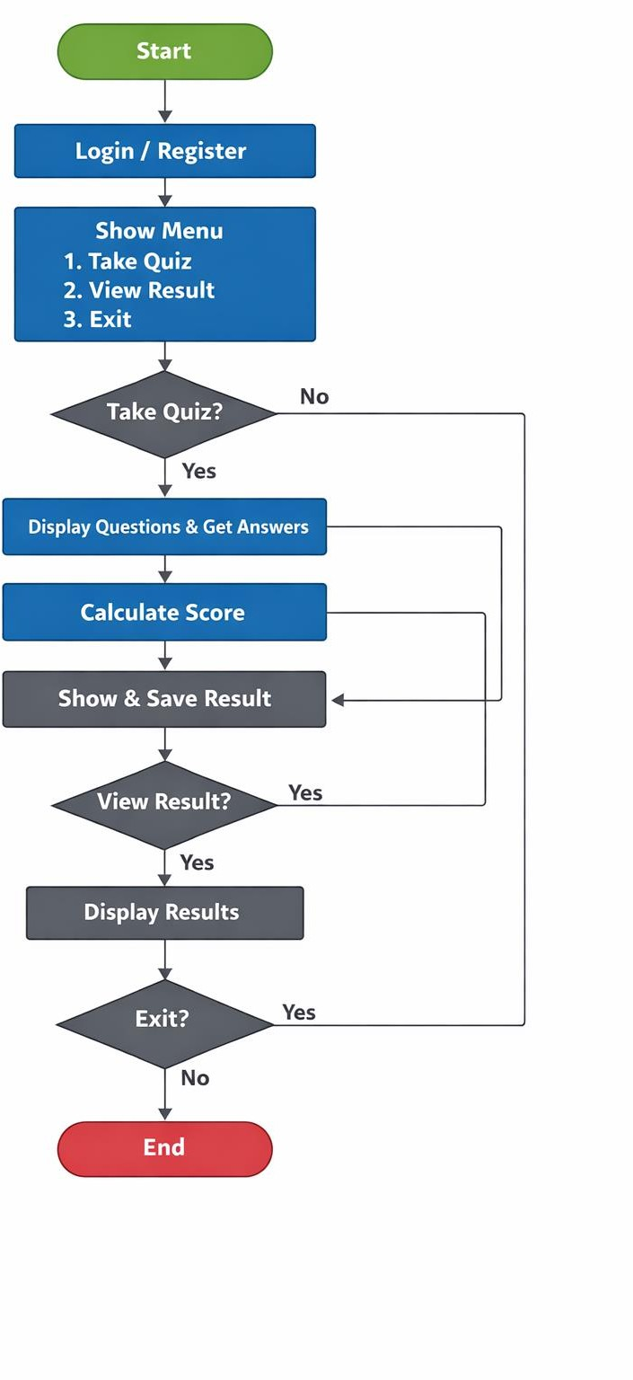

IMPLEMENTATION

import json

# Sample quiz questions quiz = [
{
"question": "What is the capital of India?",
"options": ["1. Mumbai", "2. Delhi", "3. Chennai", "4. Kolkata"],
"answer": 2
},
{
"question": "Which language is used in Python?",
"options": ["1. C", "2. Java", "3. English-like", "4. Assembly"],
"answer": 3
},
{
"question": "2 + 2 = ?",
"options": ["1. 3", "2. 4", "3. 5", "4. 6"],
"answer": 2
}
]
FILE = "results.json" def load_results():
try:
with open(FILE, "r") as f: return json.load(f)
except:
return {}

def save_results(data):
with open(FILE, "w") as f: json.dump(data, f)
def take_quiz(username): score = 0
total = len(quiz)

for q in quiz:
print("\n" + q["question"]) for opt in q["options"]:
print(opt)
ans = int(input("Enter your answer (1-4): "))

score += 1
accuracy = (score / total) * 100 print(f"\nScore: {score}/{total}") print(f"Accuracy: {accuracy:.2f}%")
return score, accuracy def main():
print("===== QAPAS System =====") username = input("Enter your name: ")
data = load_results() while True:
print("\n1. Take Quiz")
print("2. View Results") print("3. Exit")
choice = input("Enter choice: ") if choice == "1":
score, acc = take_quiz(username)

data[username] = { "score": score, "accuracy": acc
}
save_results(data) elif choice == "2":
if username in data: print("\nPrevious Result:") print(data[username])
else:
print("\nNo results found.")
elif choice == "3": print("Exiting...") break
else:
print("Invalid choice!")

if name == " main ": main()

INTEGRATION AND SYSTEM TESTING OUTPUTS

Screen Shots:

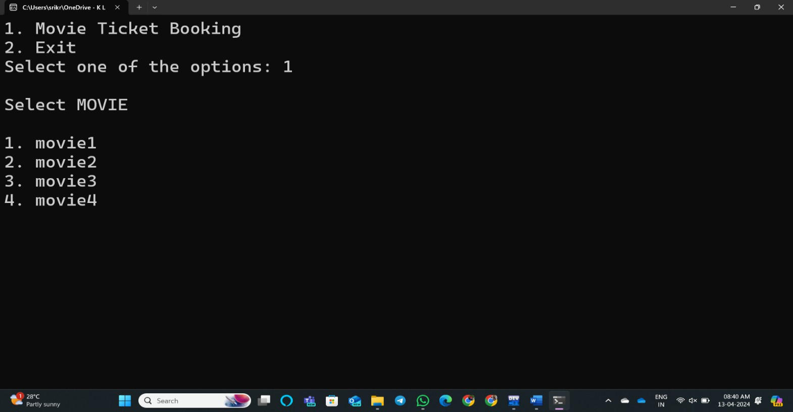

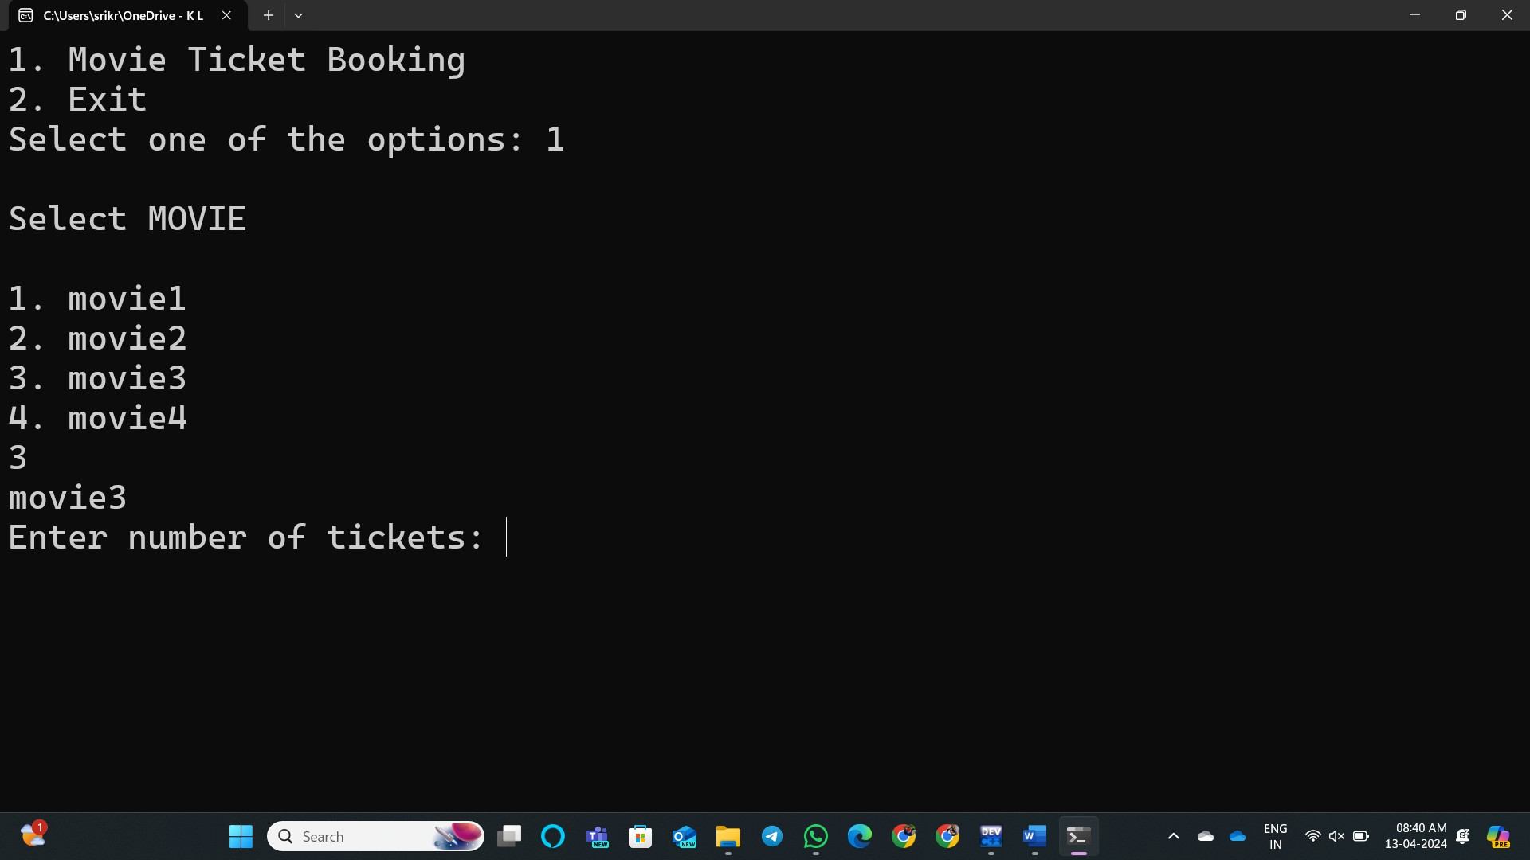
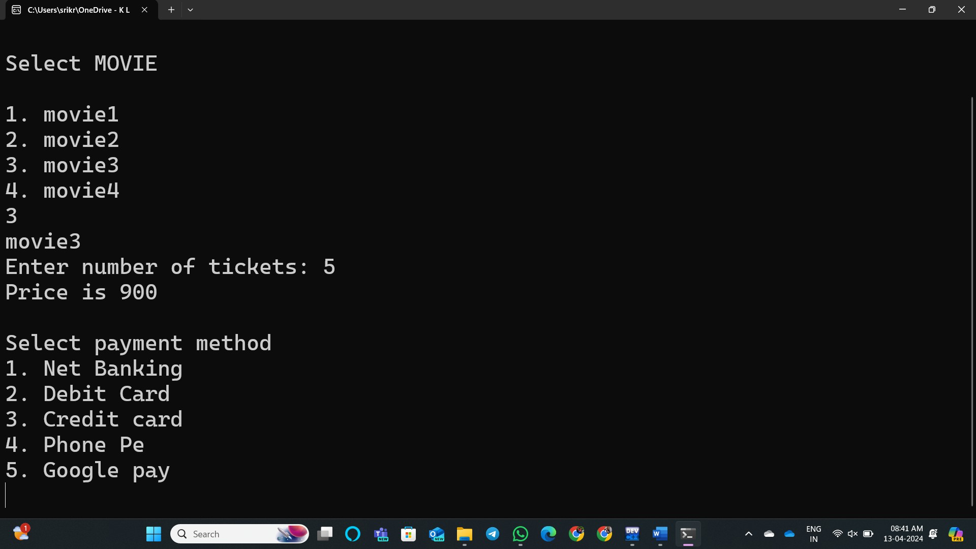

17
15

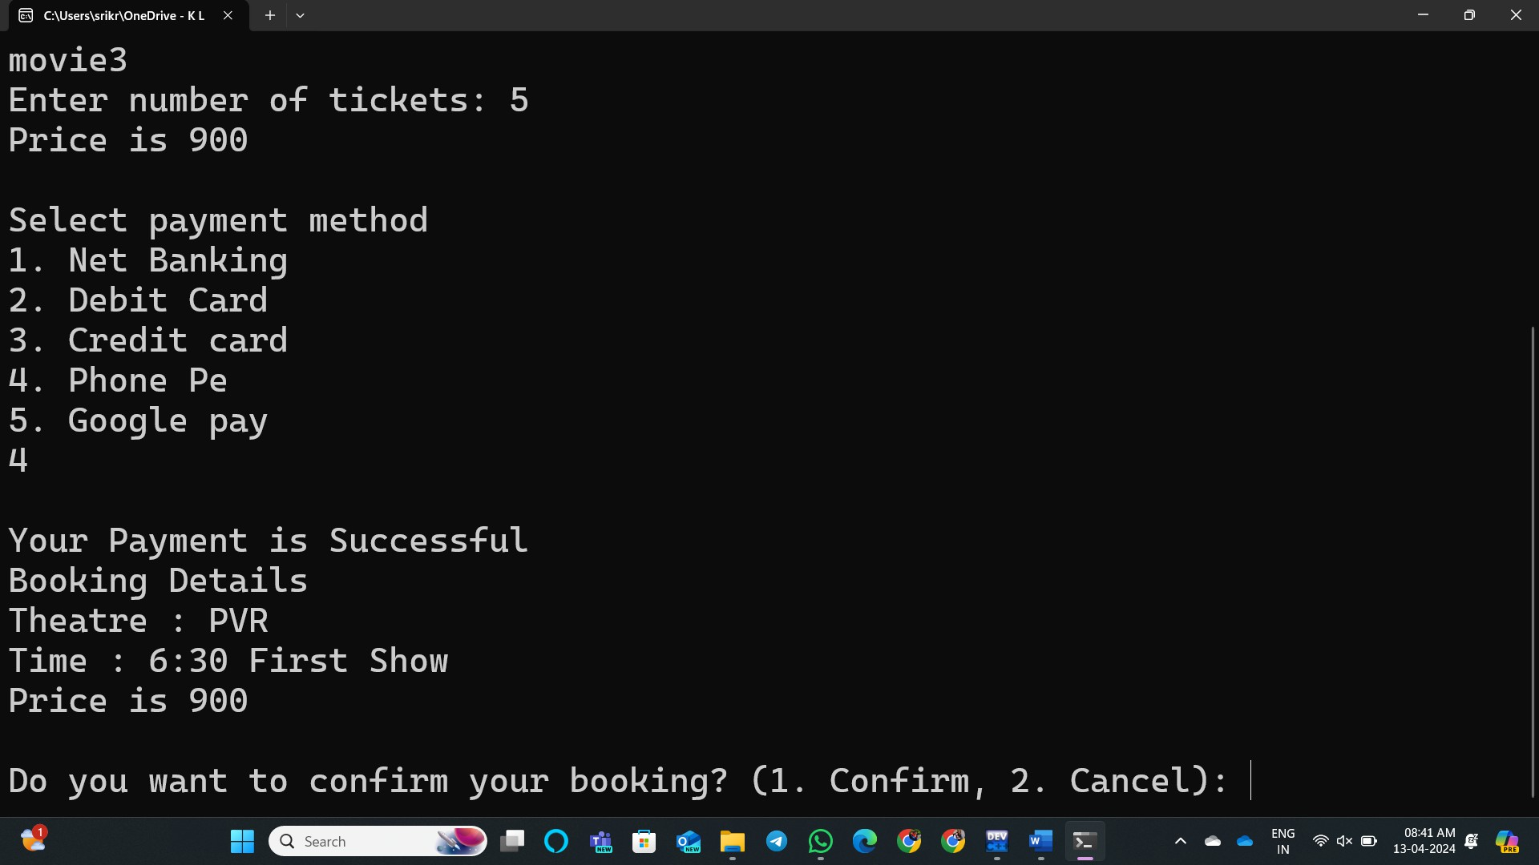
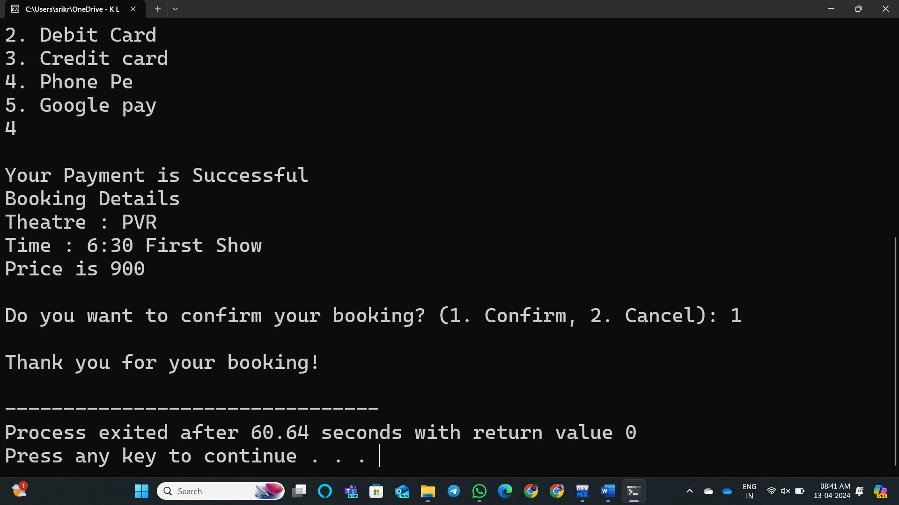

18
16

CONCLUSION
The Quiz Assessment & Performance Analytics System (QAPAS) successfully provides a modern and efficient solution for conducting quizzes and analyzing user performance. By using Python, the system simplifies quiz management, automates evaluation, and delivers instant results with accuracy.

The project helps users understand their performance through detailed analytics such as scores and accuracy, which supports better learning and improvement. It also reduces manual effort, saves time, and minimizes errors compared to traditional assessment methods.
Overall, QAPAS proves to be a useful and scalable system for educational institutions and self-learning platforms. With future enhancements like AI-based analysis and web or mobile integration, the system can become even more powerful and widely applicable in the field of digital education.

19
17

18

